**Steps:**

Installation Of MySQL.

Configuring database : Database(WFM).

login functionality:

1. Manager.
2. WFM Manager.

After Installing MySQL Follow the Commands:

1. MySQL -u root -p(enter password).
2. Create Database WFM.
3. MySQL -u root -p --database WFM <backup.SQL

Now Database is Restored.

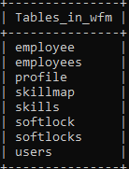

**LOGIN PAGE:**

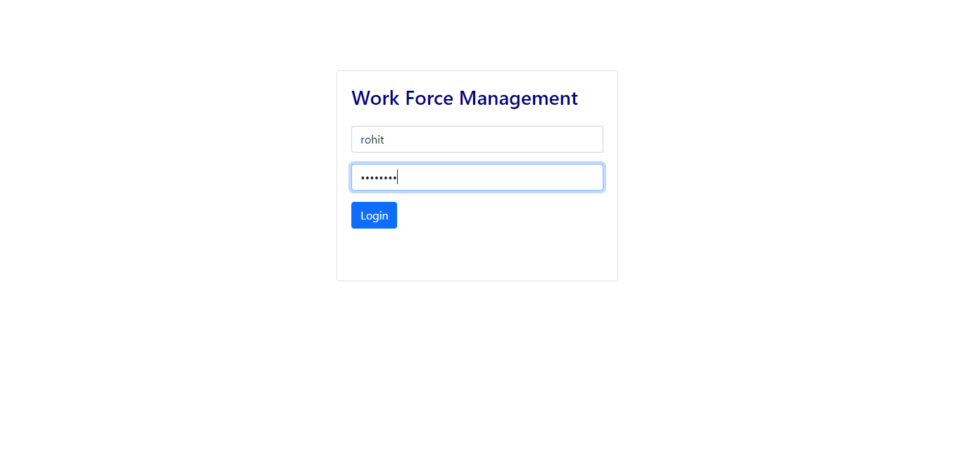

**MANAGER HOME:**

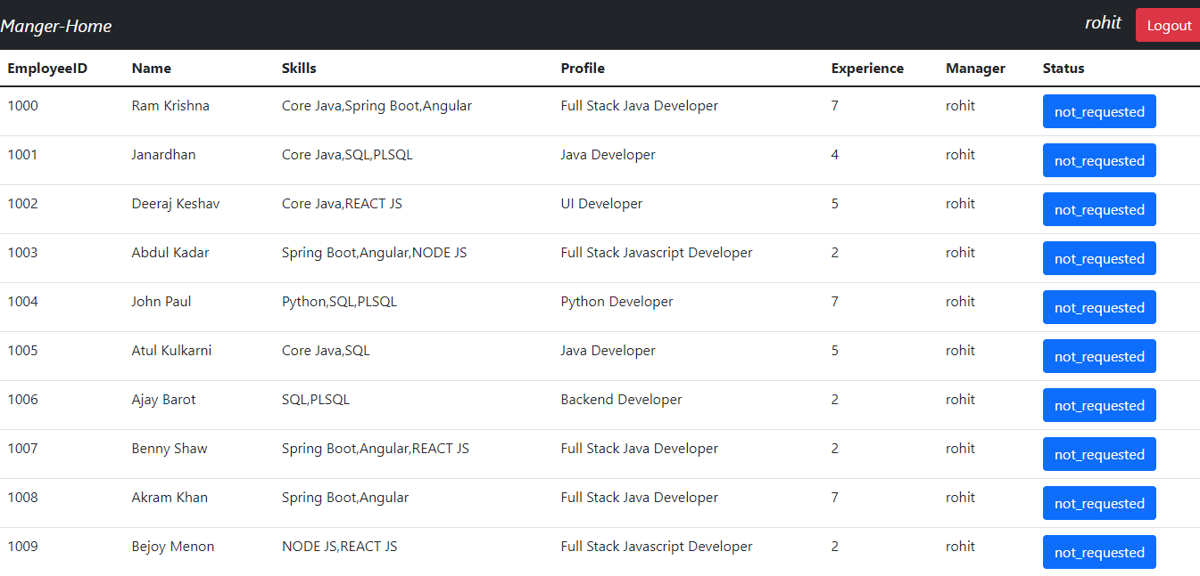

R**EQUEST CONFIRMATION**:

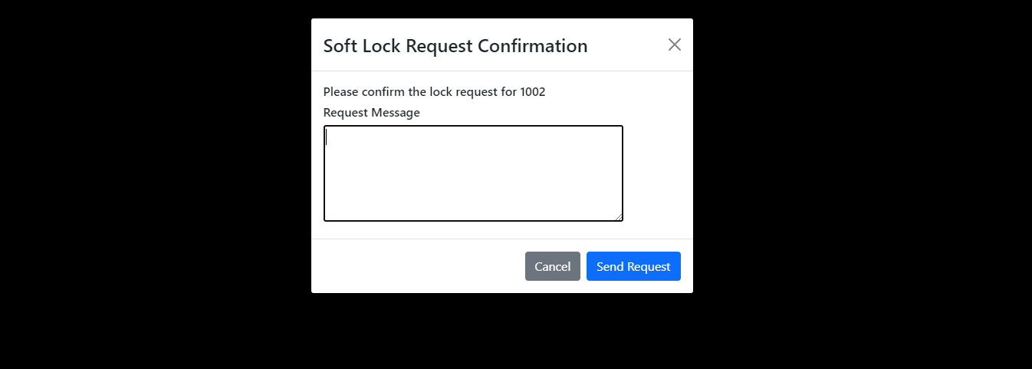

**WFM HOME:**

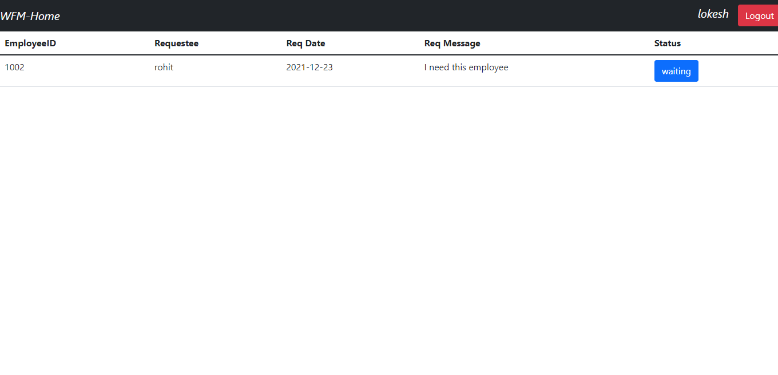

**SOFTLOCK CONFIRMATION:**

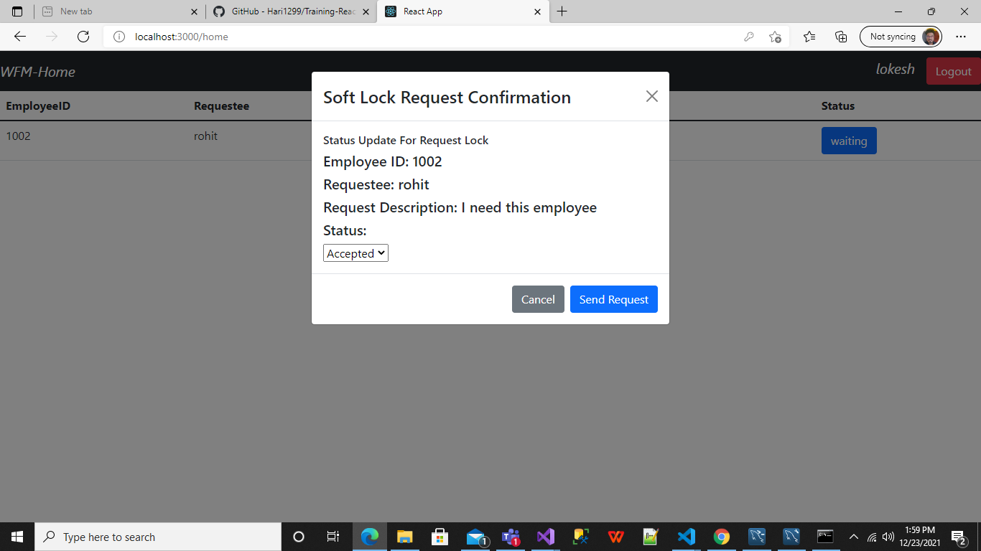

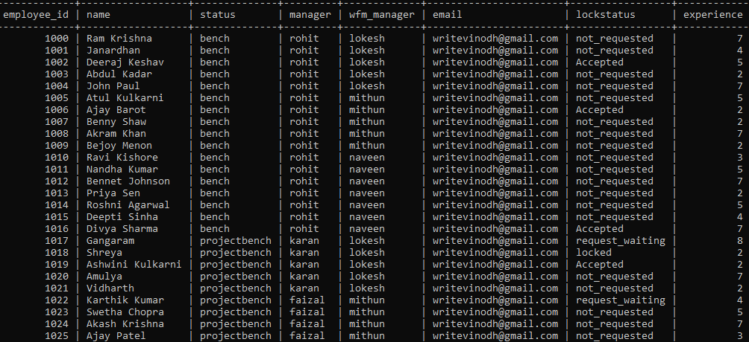

**API :**

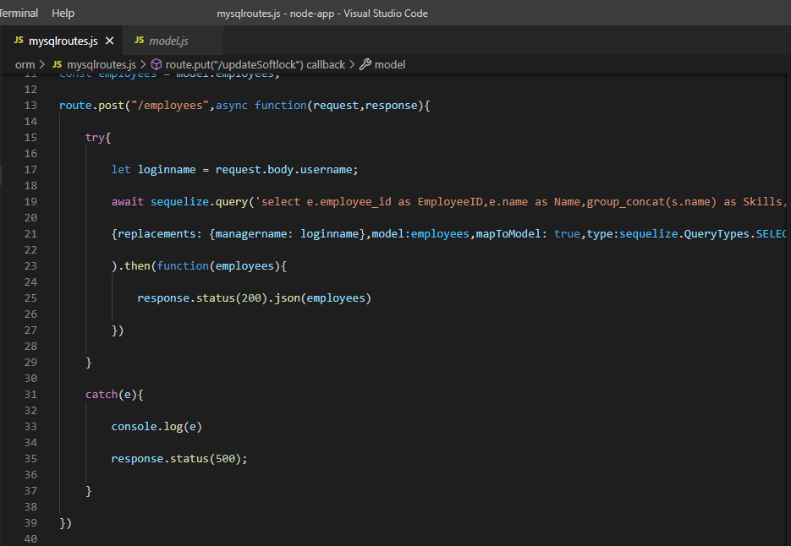

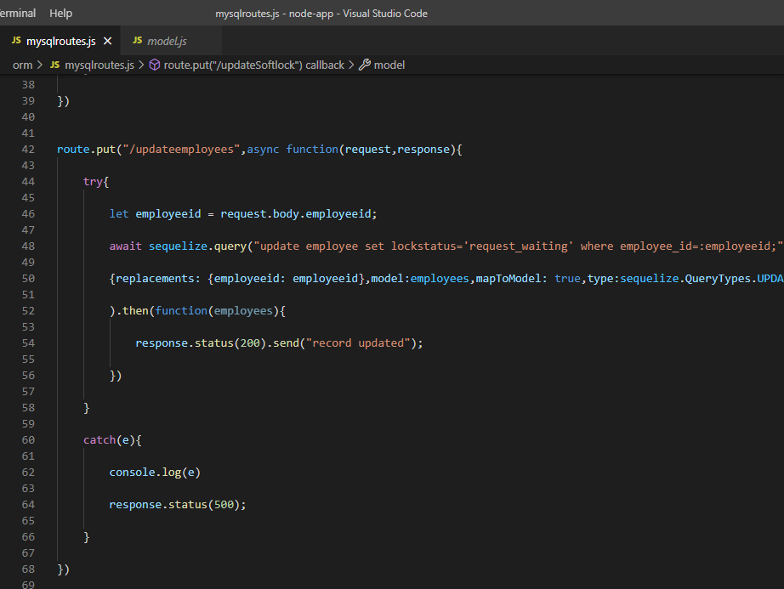

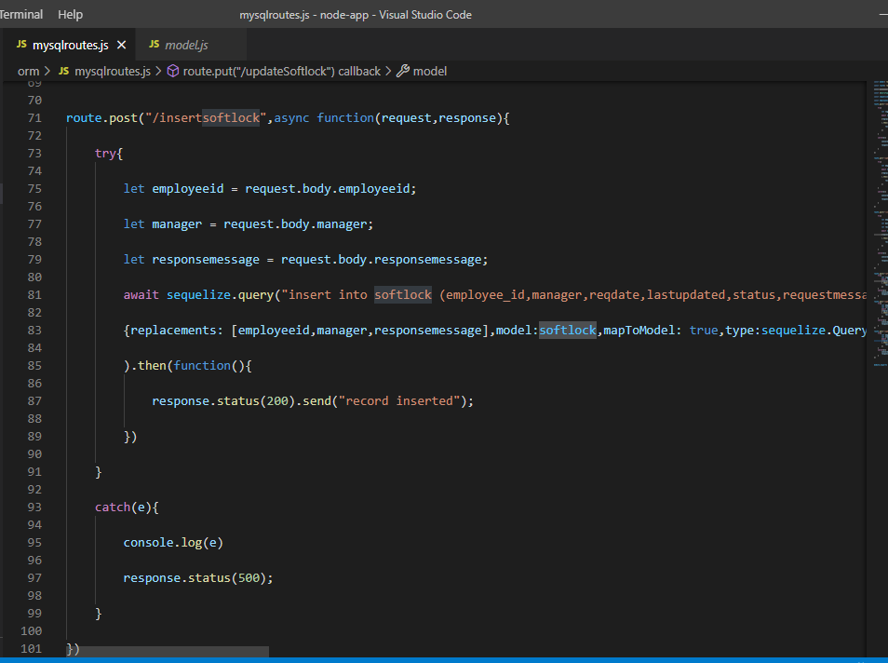

If a manager logs in then he will be able to see the employees with their respective status, skill, experience provided with soft lock button which will give a modal popup.

After clicking on the soft lock button on a particular employee ,it will show a

popup screen

If WFM Manager logs in we can observe the request sent by manager as a table

in addition with a button

If WFM Manager clicks on the button for a particular request it will raise a

popup for confirmation

After clicking Send Request Db got updated on both employee and soft lock table

THANK YOU